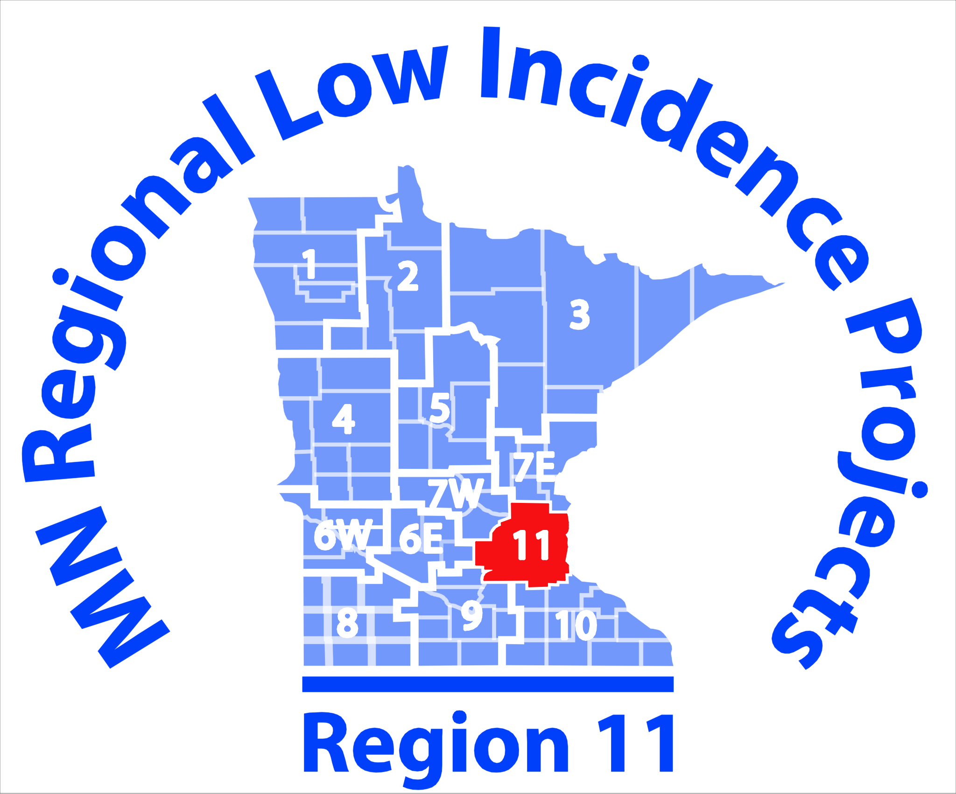

Regional PI, OHD, TBI Community of Practice Meeting
Friday, February 16th, 2018
1:00 - 3:00 p.m.

Metro ECSU
2 Pine Tree Drive - Arden Hills, MN 55112
Room Location: Oak Room
Agenda
Facilitator(s): Karen Talbert, CoP Coach
Kelly Bredeken, MN Low Incidence Projects
Time Topic Person(s) Responsible Outcome(s)
1:00 – 1:05 Welcome & Introductions All Members
1:05 – 1:45 Q & A All Members & Kelly Bredeken, Statewide Specialist,
Physical Impairments and Traumatic Brain Injury

1:45 – 2:15 Universal Design Lindsay Tsakistos, P/HD Teacher, Minneapolis

2:15- 2:55 Ability Awareness Kits Lindsay Tsakistos, P/HD Teacher, Minneapolis

2:55-3:00 Lingering Thoughts & Wrap Up All Members

Save the Date – Future Regional CoP Meetings
- Friday, May 11th, 2018 1:00-3:00

